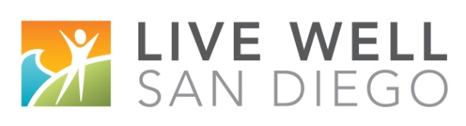
LIVE WELL SAN DIEGO YOUNG MASTER CHEF Contestant Questionnaire

Please include this questionnaire with your program’s RSVP to the LIVE WELL event no later than March 15, 2018 and fax to (858) 616-5921 along with the agency’s point of contact information. If you have a tunnel set up with the County, please email them to sheilalyn.worthington@sdcounty.ca.gov.

Agency Point of Contact Name & Phone Number: ____________________________________

Participant Name, age:
Group Home/FFA Name:
Name of School & Grade:
Meal prepared:

How did you incorporate the theme?

What do you aspire to be when you grow up?

How do you spend your free time, i.e. hobbies, sports, activities?

What is your favorite food?

What was something you learned about cooking and/or food preparation?

